CAPSTONE PROJECT REPORT
Simple File Explorer Using C++ (Linux/WSL)
Student Name: Rohit Raj
Registration Number: 2241018032
Course: B.Tech, Computer Science Engineering
Institute: Institute of Technical Education and Research (ITER)

1. Introduction
This project implements a terminal-based File Explorer application using C++17 and the <filesystem> library. It allows users to perform essential file system operations such as navigating directories, listing files, creating files, copying, moving, deleting, searching, and modifying file permissions.
The project works in a Linux / WSL environment and demonstrates understanding of system-level programming and filesystem management.

2. Objective
- To gain practical experience with Linux file operations.
- To understand and use the modern C++17 filesystem API.
- To build a user-interactive terminal utility.
- To implement recursive search and permission handling.
- To simulate a real-world file manager in command-line environment.

3. System Requirements
Component | Requirement
Operating System | Ubuntu / WSL in Windows
Programming Language | C++ (C++17 Standard)
Compiler | g++ (GNU Compiler Collection)
Editor | VS Code / Terminal
Libraries Used | <filesystem>, <chrono>, <iomanip>, <sstream>

5. Implementation Details

Commands Supported
Command | Function Performed | Example
ls | Lists files and directories | ls
ls -l | Long listing with permissions & size | ls -l
cd <dir> | Change current directory | cd testfolder
create <file> | Create a file | create notes.txt
delete <file/dir> | Delete file or folder | delete notes.txt
copy <src> <dest> | Copy file or folder | copy a.txt b.txt
move <src> <dest> | Move or rename file | move a.txt docs/
search <filename> | Search recursively | search a.txt
chmod <file> <mode> | Change permission (e.g., 644, 755) | chmod a.txt 644
exit | Exit application | exit

6. Source Code
#include <iostream>
#include <filesystem>
#include <fstream>
#include <string>
#include <iomanip>
#include <chrono>
#include <sstream>
#include <ctime>

using namespace std;
namespace fs = std::filesystem;

// -------- time helpers --------
std::time_t to_time_t(fs::file_time_type ftime) {
using namespace std::chrono;
auto sctp = time_point_cast<system_clock::duration>(
ftime - fs::file_time_type::clock::now() + system_clock::now()
);
return system_clock::to_time_t(sctp);
}

string timeString(std::tm* tm_ptr) {
if (!tm_ptr) return "0000-00-00 00:00";
std::ostringstream oss;
oss << std::put_time(tm_ptr, "%Y-%m-%d %H:%M");
return oss.str();
}

// -------- permission helpers --------
string permString(fs::perms p) {
auto bit = [&](fs::perms perm){ return (p & perm) != fs::perms::none; };
string s;
s += bit(fs::perms::owner_read) ? 'r' : '-';
s += bit(fs::perms::owner_write) ? 'w' : '-';
s += bit(fs::perms::owner_exec) ? 'x' : '-';
s += bit(fs::perms::group_read) ? 'r' : '-';
s += bit(fs::perms::group_write) ? 'w' : '-';
s += bit(fs::perms::group_exec) ? 'x' : '-';
s += bit(fs::perms::others_read) ? 'r' : '-';
s += bit(fs::perms::others_write) ? 'w' : '-';
s += bit(fs::perms::others_exec) ? 'x' : '-';
return s;
}

void chmodOctal(const fs::path& p, const string& oct) {
if (oct.size() < 3 || oct.size() > 4) throw runtime_error("Invalid mode (use like 644 or 0755)");
int v = stoi(oct, nullptr, 8);

fs::perms set = fs::perms::none;
auto add = [&](int bit, fs::perms perm){ if (v & bit) set |= perm; };

// owner
add(0400, fs::perms::owner_read);
add(0200, fs::perms::owner_write);
add(0100, fs::perms::owner_exec);
// group
add(0040, fs::perms::group_read);
add(0020, fs::perms::group_write);
add(0010, fs::perms::group_exec);
// others
add(0004, fs::perms::others_read);
add(0002, fs::perms::others_write);
add(0001, fs::perms::others_exec);

fs::permissions(p, set, fs::perm_options::replace);
}

// -------- listing --------
void listDirectory(const fs::path &path, bool longMode=false) {
cout << "\nContents of " << path << ":\n";
std::error_code ec;
for (const auto &entry : fs::directory_iterator(path, ec)) {
if (ec) { cerr << "Error: " << ec.message() << "\n"; break; }

bool isDir = entry.is_directory(ec);
if (!longMode) {
cout << (isDir ? "[DIR] " : "[FILE] ")
<< entry.path().filename().string() << '\n';
continue;
}

auto statPerms = fs::status(entry.path(), ec).permissions();
auto perms = permString(statPerms);

uintmax_t sz = 0;
if (!isDir) {
std::error_code szec;
sz = fs::file_size(entry.path(), szec);
if (szec) sz = 0;
}

auto lwt_ec = std::error_code{};
auto ftime = fs::last_write_time(entry.path(), lwt_ec);
std::time_t ctt = lwt_ec ? std::time_t{} : to_time_t(ftime);
std::tm* tm_ptr = lwt_ec ? nullptr : std::localtime(&ctt);
string tstr = timeString(tm_ptr);

cout << (isDir ? 'd' : '-') << perms << " "
<< setw(10) << sz << " "
<< tstr << " "
<< entry.path().filename().string() << '\n';
}
}

// -------- file ops --------
void createFile(const fs::path &path) {
ofstream file(path);
if (file) cout << "File created: " << path.filename().string() << '\n';
else cout << "Error creating file!\n";
}

void deleteFile(const fs::path &path) {
if (fs::exists(path)) {
fs::remove_all(path);
cout << "Deleted: " << path.filename().string() << '\n';
} else {
cout << "File or directory not found!\n";
}
}

void copyFile(const fs::path &src, const fs::path &dest) {
try {
fs::path realDest = dest;
if (fs::exists(dest) && fs::is_directory(dest)) {
realDest = dest / src.filename();
}
fs::copy(src, realDest, fs::copy_options::overwrite_existing | fs::copy_options::recursive);
cout << "Copied " << src.filename().string() << " to " << realDest.string() << '\n';
} catch (const exception &e) {
cout << "Error copying file: " << e.what() << '\n';
}
}

void moveFile(const fs::path &src, const fs::path &dest) {
try {
fs::path realDest = dest;
if (fs::exists(dest) && fs::is_directory(dest)) {
realDest = dest / src.filename();
}
fs::rename(src, realDest);
cout << "Moved " << src.filename().string() << " to " << realDest.string() << '\n';
} catch (const exception &e) {
cout << "Error moving file: " << e.what() << '\n';
}
}

void searchFile(const fs::path &path, const string &filename) {
cout << "Searching for \"" << filename << "\" in " << path << "...\n";
bool found = false;
std::error_code ec;
for (const auto &entry : fs::recursive_directory_iterator(path, ec)) {
if (ec) { cerr << "Error: " << ec.message() << "\n"; break; }
if (entry.path().filename() == filename) {
cout << "Found at: " << entry.path() << '\n';
found = true;
}
}
if (!found) cout << "No file named \"" << filename << "\" found.\n";
}

int main() {
fs::path currentPath = fs::current_path();
string command;

cout << "===== Simple File Explorer (C++ - LinuxOS) =====\n";
cout << "Type 'help' to view available commands.\n";

while (true) {
cout << "\n[" << currentPath << "]$ ";
cin >> command;

if (command == "ls") {
string rest;
getline(cin, rest);
bool longMode = (rest.find("-l") != string::npos);
listDirectory(currentPath, longMode);
}
else if (command == "cd") {
string dir; cin >> dir;
fs::path newPath = (dir == "..") ? currentPath.parent_path() : currentPath / dir;
if (fs::exists(newPath) && fs::is_directory(newPath)) currentPath = newPath;
else cout << "Invalid directory.\n";
}
else if (command == "create") {
string filename; cin >> filename;
createFile(currentPath / filename);
}
else if (command == "delete") {
string name; cin >> name;
deleteFile(currentPath / name);
}
else if (command == "copy") {
string src, dest; cin >> src >> dest;
copyFile(currentPath / src, currentPath / dest);
}
else if (command == "move") {
string src, dest; cin >> src >> dest;
moveFile(currentPath / src, currentPath / dest);
}
else if (command == "search") {
string name; cin >> name;
searchFile(currentPath, name);
}
else if (command == "chmod") {
string filename, mode; cin >> filename >> mode;
try {
chmodOctal(currentPath / filename, mode);
cout << "Permissions updated for: " << filename << '\n';
} catch (const exception& e) {
cout << "chmod error: " << e.what() << '\n';
}
}
else if (command == "help") {
cout << "\nAvailable commands:\n"
<< "ls - List files and directories\n"
<< "ls -l - Long list (perms/size/time)\n"
<< "cd <dir> - Change directory\n"
<< "create <file> - Create a file\n"
<< "delete <file/dir> - Delete file or directory (recursive)\n"
<< "copy <src> <dest> - Copy file/folder (dest may be a directory)\n"
<< "move <src> <dest> - Move or rename (dest may be a directory)\n"
<< "search <filename> - Search file recursively by name\n"
<< "chmod <file> <mode> - Change permission (octal, e.g., 644, 755)\n"
<< "help - Show available commands\n"
<< "exit - Quit program\n";
}
else if (command == "exit") {
cout << "Exiting File Explorer...\n";
break;
}
else {
cout << "Unknown command! Type 'help' for options.\n";
}
}
return 0;
}

7. Output Screenshots
- Program Start
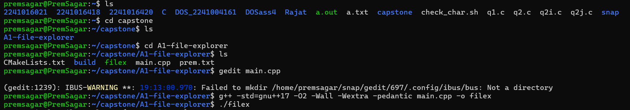

- Listing Files (ls)
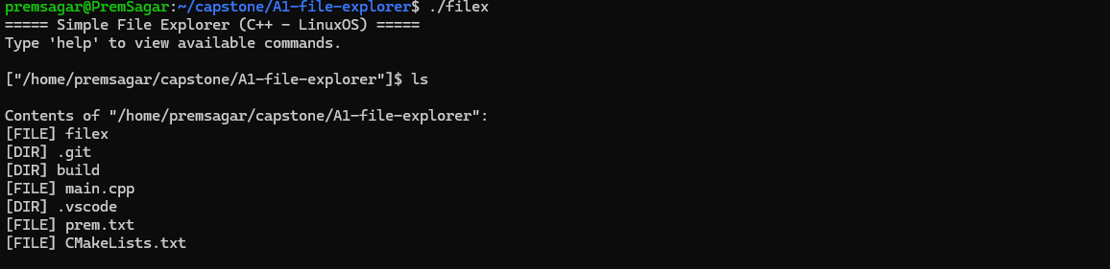

- Long Listing (ls -l)
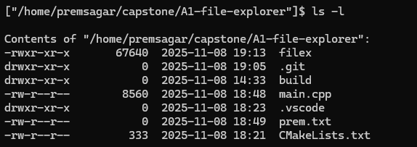
- Creating File (create demo.txt)

- Searching File (search demo.txt)
- Changing Permissions (chmod demo.txt 644)
- Copying File (copy demo.txt copy.txt)
- Moving File (move copy.txt testfolder/)
- Deleting File (delete demo.txt)

8. Conclusion
This project successfully demonstrates the development of a Linux-based File Explorer using C++17.
It enabled hands-on practice with:
- Filesystem traversal
- Recursive search
- Permission handling
- Command-based user interface
The project fulfills all requirements of the A1 Capstone Module and builds strong fundamentals in system-level programming.

